

TLS Handshake Visualizer and Vulnerability Scanner

CAPSTONE PROJECT REPORT

A Capstone Project Report submitted in partial fulfilment of the requirements for the Course of

CSA5110 - Cryptography and Network Security

to the award of the degree of

BACHELOR OF TECHNOLOGY IN
ARTIFICIAL INTELLIGENCE AND DATA SCIENCE
(BRANCH)

Submitted by
P. Ruthish (192224283)

Under the Supervision of
Dr. Nitisha J
SIMATS ENGINEERING
Saveetha Institute of Medical and Technical Sciences Chennai-602105

SEPTEMBER 2026

SIMATS ENGINEERING
Saveetha Institute of Medical and Technical Sciences Chennai-602105

BONAFIDE CERTIFICATE

This is to certify that the Capstone Project entitled “TLS Handshake Visualizer and Vulnerability Scanner” has been carried out by P. Ruthish under the supervision of Dr . Nithisha J and is submitted in partial fulfilment of the requirements for the current semester of the B.Tech Computer Science Engineering – Artificial Intelligence And Data Science program at Saveetha Institute of Medical and Technical Sciences, Chennai.

COURSE COORDINATOR COURSE FACULTY
Dr T Sangeetha Dr. Nitisha J
Professor Professor
Computational Intelligence Computational Intelligence
SIMATS Engineering, SIMATS Engineering,
SIMATS, Chennai – 602105. SIMATS, Chennai – 602105.

SIMATS ENGINEERING
Saveetha Institute of Medical and Technical Sciences Chennai-602105

DECLARATION

I, P. Ruthish of the [CSE - AI&DS], SIMATS Engineering, Saveetha Institute of Medical and Technical Sciences, Chennai, hereby declare that the Capstone Project Work entitled “[TLS Handshake Visualizer and Vulnerability Scanner]” is the result of our own bonafide efforts. To the best of our knowledge, the work presented herein is original, accurate, and has been carried out in accordance with the principles of engineering ethics and academic integrity. All sources, references, data, and other materials used in the project have been appropriately acknowledged. We further declare that the data, results, analysis, and findings presented in this report have not been fabricated, falsified, or manipulated. Any external tools, software, datasets, computational resources, or AI-assisted tools used during the project have been appropriately disclosed. We confirm that all applicable ethical, academic, institutional, and professional requirements have been duly followed throughout the planning, execution, analysis, and documentation of the project.

Place:CHENNAI
Date:03/09/2026

Signature of the Student with Name

SIMATS ENGINEERING
Saveetha Institute of Medical and Technical Sciences Chennai-602105

Individual Contribution Statement

Student Name / Register No. | Specific  Responsibilities | Design & Development Contribution | Testing & Analysis  Contribution | Report Contribution | Approx.  Contribution (%)
P. Ruthish  192224283 | Module 1: TLS Connection & Certificate Analysis | TLS connection establishment; SNI handling; TLS version and cipher extraction; certificate parsing; certificate validity and hostname analysis. | Tested TLS 1.3, TLS 1.2, certificate-validity and hostname-mismatch cases; analysed connection and certificate results. | Module 1 design and implementation; Chapter 3 system design; Chapter 4 implementation/testing; Individual Reflection. | 34%
Devanarayan J 192524314 | Module 2: TLS Handshake Visualization & Reporting | TLS 1.2 and TLS 1.3 handshake sequence representation; handshake visualization; parameter display; JSON/HTML report generation. | Verified handshake-stage ordering, parameter display, visualization readability and report-generation results. | Visualization and reporting design; Chapter 4 results and figures; implementation documentation; Individual Reflection. | 33%
 | Module 3: Vulnerability Assessment, Security Rules & Scoring | Vulnerability detection rules; certificate and cipher weakness classification; security scoring model; finding severity assignment. | Executed positive and negative security tests; validated certificate, hostname and weak-cipher findings; analysed scores and false-positive handling. | Vulnerability analysis; security scoring; Chapter 5 conclusion/reflection; references and appendices. | 33%
Total |  |  |  |  | 100%

ABSTRACT

The increasing use of web applications, cloud services, online banking, and connected digital systems has made secure communication over computer networks an essential requirement. Transport Layer Security (TLS) is widely used to protect data transmitted between clients and servers by providing confidentiality, integrity, authentication, and secure session establishment. However, TLS involves several handshake messages and security parameters that can be difficult for students and security practitioners to understand or inspect using conventional command-line tools. Misconfigured certificates, deprecated protocol versions, weak cipher suites, and hostname mismatches may also introduce security weaknesses.
The proposed project, TLS Handshake Visualizer and Vulnerability Scanner, is designed to provide a practical platform for analysing TLS connections, visualizing the handshake sequence, and identifying common configuration and certificate-related security weaknesses. The system establishes a TLS connection with a specified server and extracts important parameters such as TLS version, negotiated cipher suite, server certificate information, certificate validity period, subject name, and Subject Alternative Name (SAN).
The proposed system is divided into three major functional areas. Module 1, TLS Connection and Certificate Analysis, establishes the secure connection and extracts protocol and certificate parameters. Module 2, TLS Handshake Visualization and Reporting, represents the major TLS 1.2 and TLS 1.3 handshake stages and generates structured JSON and HTML reports. Module 3, Vulnerability Assessment, Security Rules and Scoring, evaluates the collected parameters against predefined security rules and identifies conditions such as expired certificates, not-yet-valid certificates, hostname mismatches, weak or legacy cipher configurations, and deprecated TLS protocol usage where applicable.
The system applies cryptographic and network-security concepts including Transport Layer Security, X.509 certificates, public-key cryptography, symmetric encryption, digital signatures, certificate validation, cipher-suite negotiation, and secure communication principles. A project-defined security scoring model assigns severity deductions to detected findings and produces a transparent score out of 100.
The system is implemented as a software-based prototype using Python, the Python SSL/TLS facilities, certificate-parsing support, OpenSSL test services, and HTML/JSON reporting. Controlled validation is performed using local TLS 1.2 and TLS 1.3 endpoints with valid certificates, expired certificates, hostname mismatches, and weak cipher configurations. The testing process verifies TLS parameter extraction, handshake representation, vulnerability classification, security scoring, safe handling of failed connections, and report generation.
The expected outcome of the project is a practical and educational TLS security analysis tool that makes handshake behaviour easier to understand while providing transparent detection of common TLS configuration weaknesses. The project demonstrates how cryptographic concepts and network-security techniques can be integrated into a software system to support TLS analysis, vulnerability identification, visualization, and security reporting.
Keywords: Transport Layer Security, TLS Handshake, TLS 1.2, TLS 1.3, X.509 Certificate, Vulnerability Scanner, Cipher Suite, Certificate Validation, Security Visualization.

TABLE OF CONTENTS

Sl.  No | Title | Page  No
i | CERTIFICATE FROM THE SUPERVISOR | ii
ii | DECLARATION BY THE CANDIDATE | iii
Iii | INDIVIDUAL CONTRIBUTION STATEMENT | iv
iv | ABSTRACT | v
v | LIST OF FIGURES | vi
vi | LIST OF TABLES | vii
vii | LIST OF ABBREVIATIONS | viii
1 | CHAPTER 1: Introduction | 1
2 | CHAPTER 2: Literature Review | 2
3 | CHAPTER 3: Engineering Design & Trade-offs, Sustainability,  Ethics, Safety, Risk & Security | 3
4 | CHAPTER 4: Implementation, Testing & Results, Project  Management | 4
5 | CHAPTER 5: Conclusion & Reflection | 5
 | References
 | Appendices

LIST OF FIGURES

Figure No. | Figure Name | Page No.
Figure 1.1 | TLS Handshake Visualizer Overview | 1
Figure 1.2 | TLS Security Assessment Concept | 1
Figure 3.1 | Overall TLS Handshake Visualizer System Architecture | 8
Figure 3.2 | TLS Connection and Certificate Analysis Architecture | 9
Figure 3.3 | TLS Handshake Visualization Flow | 9
Figure 3.4 | Certificate and Security Rule Evaluation | 10
Figure 3.5 | Vulnerability Assessment and Reporting Architecture | 10
Figure 3.6 | TLS Scan Workflow | 10
Figure 3.7 | Vulnerability Finding and Safe Failure Handling | 11
Figure 3.8 | Project Data Flow | 11
Figure 4.1 | TLS Scanner Dashboard and Handshake Observation Interface | 13
Figure 4.2 | Certificate Analysis Interface | 13
Figure 4.3 | Security Finding and Scoring View | 14
Figure 4.4 | TLS Handshake Stage View | 14
Figure 4.5 | Generated Security Report | 14
Figure 4.6 | Validation Findings and Safe Failure Results | 16
Figure 4.7 | Testing and Performance Results | 16

LIST OF TABLES

Table No. | Table Name | Page No.
Table 1.1 | Project Objectives and Expected Outcomes | 2
Table 1.2 | Requirements, Constraints and Assumptions | 3
Table 2.1 | Comparison of Existing TLS Analysis Tools | 5
Table 2.2 | Literature Review Summary | 6
Table 3.1 | Functional and Non-Functional Requirements | 7
Table 3.2 | TLS Security Rules and Severity Levels | 10
Table 3.3 | Risk Assessment and Mitigation Measures | 12
Table 4.1 | Implementation Environment and Tools | 13
Table 4.2 | Test Cases and Expected Results | 15
Table 4.3 | Actual Test Results | 17
Table 4.4 | Security Score Evaluation | 18
Table 4.5 | Performance Evaluation Results | 19
Table 4.6 | Project Schedule and Milestones | 20
Table 4.7 | Team Contribution Summary | 21
Table 4.4 | Comparison with Existing Solutions and Objective Achievement | 17
Table 4.5 | Project Roles and Contributions | 18

LIST OF ABBREVIATIONS / SYMBOLS

Symbol / Abbreviation | Description | Unit
TLS | Transport Layer Security | N/A
SSL | Secure Sockets Layer | N/A
TCP | Transmission Control Protocol | N/A
IP | Internet Protocol | N/A
HTTPS | Hypertext Transfer Protocol Secure | N/A
SNI | Server Name Indication | N/A
X.509 | X.509 Public Key Certificate Standard | N/A
CA | Certificate Authority | N/A
PKI | Public Key Infrastructure | N/A
CN | Common Name | N/A
SAN | Subject Alternative Name | N/A
RSA | Rivest–Shamir–Adleman | N/A
ECDHE | Elliptic Curve Diffie–Hellman Ephemeral | N/A
AES | Advanced Encryption Standard | N/A
GCM | Galois/Counter Mode | N/A
SHA | Secure Hash Algorithm | N/A
HMAC | Hash-based Message Authentication Code | N/A
CBC | Cipher Block Chaining | N/A
API | Application Programming Interface | N/A
JSON | JavaScript Object Notation | N/A
HTML | HyperText Markup Language | N/A
CLI | Command-Line Interface | N/A
CVE | Common Vulnerabilities and Exposures | N/A
MITM | Man-in-the-Middle | N/A
DoS | Denial of Service | N/A
UI | User Interface | N/A

CHAPTER 1

INTRODUCTION AND ENGINEERING PROBLEM

1.1 Background

Transport Layer Security (TLS) is a fundamental security protocol used to protect communication between clients and servers over computer networks. It is widely used in HTTPS, secure APIs, cloud applications, email services, and other network-based systems where confidential information must be transmitted securely.

TLS provides three major security properties: confidentiality, integrity, and authentication. Confidentiality prevents unauthorized parties from reading transmitted information, integrity helps detect modification of data during transmission, and authentication allows a client to verify the identity of the server through digital certificates.

The TLS handshake is the initial negotiation process through which the client and server establish the parameters required for secure communication. During the handshake, the communicating parties negotiate the TLS version and cryptographic algorithms, exchange required information, validate certificates, establish cryptographic keying material, and complete the process before application data is transmitted.

TLS 1.2 and TLS 1.3 are particularly important versions for modern secure communication. TLS 1.3 simplifies the handshake and removes several older cryptographic mechanisms, while TLS 1.2 continues to exist in many real-world systems for compatibility.

Despite the importance of TLS, the handshake process can be difficult for students, developers, and security learners to understand because the information produced by conventional command-line utilities is highly technical. A typical TLS diagnostic output may contain protocol versions, cipher suites, certificate details, signature algorithms, certificate verification messages, and connection errors without presenting the complete process in an intuitive manner.

1.2 Need for the Project

The need for the TLS Handshake Visualizer and Vulnerability Scanner arises because:

TLS is widely used for securing network communication, but the underlying handshake process is difficult to understand from raw technical output.

Certificate-related security problems can expose systems to risk, particularly when certificates are expired, invalid, or issued for a different hostname.

Different TLS versions provide different handshake mechanisms, making it useful to visualize TLS 1.2 and TLS 1.3 separately.

Cipher-suite selection affects communication security, and legacy or weak cipher configurations may require security attention.

Manual TLS analysis is time-consuming, especially when several security parameters must be checked together.

Command-line diagnostic tools provide detailed information but may be difficult for beginners to interpret, creating a gap between raw protocol data and understandable security analysis.

Therefore, the project provides an educational and engineering-oriented approach for observing TLS handshakes and identifying selected configuration-related security issues.

1.3 Problem Statement

Modern network applications depend heavily on TLS to provide secure communication between clients and servers. However, understanding the TLS handshake and determining whether a TLS endpoint is configured securely can be difficult when analysis depends primarily on raw command-line output or manual inspection.

The engineering problem is to design and develop a TLS analysis system capable of observing TLS connections, visualizing handshake stages, analyzing X.509 certificates, detecting selected security configuration weaknesses, and presenting the results through structured security reports while safely handling connection failures and unsupported configurations.

The system must consider multiple interacting engineering requirements, including:

Security versus usability — security information must be sufficiently detailed while remaining understandable to the user.

Detailed analysis versus implementation complexity — the system should provide useful TLS information without attempting to implement an entire TLS protocol stack.

Security assessment versus false positives — findings should be generated only when the available evidence supports the corresponding rule.

Compatibility versus security — TLS 1.2 may be required for compatibility even though TLS 1.3 is preferred for modern deployments.

1.4 Project Aim

The aim of this project is to design and develop a TLS Handshake Visualizer and Vulnerability Scanner that analyzes TLS connections, visualizes handshake stages, evaluates certificate and cryptographic configurations, identifies selected security weaknesses, and generates structured security reports.

1.5 Project Objectives

Table 1.1: Project Objectives
Objective No. | Objective
1 | To design a system for establishing and analyzing TLS connections.
2 | To identify the negotiated TLS protocol version and cipher suite.
3 | To extract and analyze X.509 certificate information.
4 | To visualize the major stages of TLS 1.2 and TLS 1.3 handshakes.
5 | To implement deterministic security rules for detecting selected TLS configuration weaknesses.
6 | To detect certificate-related issues such as expired certificates and hostname mismatches.
7 | To identify selected legacy or weak cryptographic configurations such as legacy cipher usage.

1.6 Scope

Included

The proposed system includes:

TLS endpoint input and connection establishment.

TLS connection analysis.

TLS 1.2 analysis.

TLS 1.3 analysis.

Negotiated TLS-version identification.

Negotiated cipher-suite identification.

Server certificate extraction.

X.509 certificate information analysis.

Certificate validity-period checking.

Excluded

Full enterprise-scale vulnerability management.

Complete penetration testing of arbitrary Internet systems.

Exploitation of discovered vulnerabilities.

Development of a new TLS protocol implementation.

Hardware Security Module integration.

Full certificate-authority infrastructure.

Assumptions

The system operates under the following assumptions:

The target endpoint is reachable through the configured network connection.

The target service supports TLS communication.

1.7 Expected Engineering Outcome

The expected engineering outcome is a functional prototype of a TLS Handshake Visualizer and Vulnerability Scanner capable of analyzing TLS endpoints and presenting security-related observations in an understandable form.

The completed system is expected to provide:

A functional TLS connection-analysis module.

Identification of TLS 1.2 and TLS 1.3 connections.

Negotiated cipher-suite information.

X.509 certificate information and validation results.

TLS handshake-stage visualization.

Detection of expired certificates.

CHAPTER 2

LITERATURE REVIEW AND EXISTING SOLUTIONS

2.1 Review Method

The literature review for the TLS Handshake Visualizer and Vulnerability Scanner was conducted by examining research papers, technical standards, security guidance, open-source tools, and existing TLS-analysis approaches related to Transport Layer Security, TLS handshakes, X.509 certificates, cipher suites, certificate validation, and TLS vulnerability assessment.

2.2.1 Review of Existing Work

TLS has evolved through multiple versions to improve communication security and remove weaknesses from older protocol designs. TLS 1.2 introduced widely adopted cryptographic mechanisms and remains supported by many systems. TLS 1.3 further simplifies the handshake, reduces unnecessary protocol complexity, and removes several legacy cryptographic options.

TLS 1.3 uses a streamlined handshake in which the client and server negotiate cryptographic parameters and establish shared secrets before application data is exchanged. The handshake includes stages such as ClientHello, ServerHello, EncryptedExtensions, Certificate, CertificateVerify, and Finished.

TLS 1.2 uses a comparatively more extensive handshake sequence involving messages such as ClientHello, ServerHello, Certificate, ServerKeyExchange, ServerHelloDone, ClientKeyExchange, ChangeCipherSpec, and Finished.

Understanding these differences is important for the proposed project because the visualizer must represent the logical sequence of the two protocol versions accurately.

2.2.2 X.509 Certificates and Authentication

Digital certificates are an important component of TLS server authentication. An X.509 certificate binds an identity to a public key and is normally issued by a trusted Certificate Authority.

During certificate validation, several properties can be relevant, including:

Certificate validity period.

Certificate issuer.

Subject information.

Subject Alternative Name (SAN).

Public-key information.

Signature information.

Hostname identity.

An expired certificate can cause a TLS client to reject the connection, while a hostname mismatch indicates that the certificate does not properly identify the requested server. These conditions are therefore important security checks for the proposed scanner.

2.3 Comparative Analysis

Table 2.1: Comparison of Existing TLS Analysis Tools
Existing Approach | Advantages | Limitations | Relevance to Proposed Work
OpenSSL s_client | Detailed TLS connection diagnostics; widely available; provides certificate and cipher information | Raw command-line output; difficult for beginners to interpret visually | Provides the underlying TLS observation approach
testssl.sh | Automated and extensive TLS security testing | Large amount of technical output; visualization is limited | Provides reference for automated security-rule evaluation
Qualys SSL Labs | Comprehensive TLS assessment and clear security reporting | Primarily designed for practical server assessment; external service dependency | Demonstrates professional TLS assessment and reporting
Manual TLS analysis | Flexible and useful for learning protocol behavior | Time-consuming and prone to interpretation errors | Highlights the need for automation
Proposed TLS Handshake Visualizer and Vulnerability Scanner | Combines TLS analysis, handshake visualization, certificate inspection, selected vulnerability checks, scoring, and reporting | Limited to implemented security rules; not a complete enterprise scanner | Provides an educational and transparent integrated solution

Table 2.2: Literature Review Summary
Area | Key Observation | Application in Proposed Project
TLS protocol design | TLS provides secure authenticated communication | Forms the technical foundation of the system
TLS 1.2 | Widely deployed and supports several configurations | Included for compatibility analysis
TLS 1.3 | Simplifies and strengthens the TLS handshake | Included as the modern TLS case
X.509 certificates | Provide server identity and public-key binding | Certificate analysis module
Certificate validation | Validity and hostname checks are essential | Security finding rules
Cipher suites | Cryptographic configuration affects security | Cipher analysis
TLS assessment tools | Existing tools provide detailed diagnostics | Used as references for system design
Visualization | Raw TLS information can be difficult to understand | Handshake visualizer
Automated assessment | Rules can reduce manual analysis | Vulnerability scanner
Security reporting | Structured results improve interpretation | JSON and HTML reports

2.4 Research / Engineering Gap

The review indicates that existing TLS tools provide strong diagnostic and security-testing capabilities, but there remains an educational engineering gap between raw TLS protocol information and an understandable visual representation of the handshake and security findings.

Command-line tools can expose detailed connection information, but users must interpret the output manually. Comprehensive scanners provide broader testing but can produce large quantities of information that are difficult for beginners to connect with individual TLS handshake stages.

The engineering gap addressed by this project is therefore the lack of a focused, transparent, educational system that combines protocol observation, handshake visualization, certificate analysis, selected vulnerability detection, security scoring, and structured reporting in one workflow.

The project also emphasizes safe interpretation of results. A failed connection should not automatically be classified as a vulnerability. Instead, the system records the failure and determines whether sufficient evidence exists to generate a security finding.

2.5 Proposed Contribution

The proposed project contributes a prototype that integrates several TLS-security concepts into one analysis workflow:

The system establishes TLS connections and records important negotiated parameters.

The system identifies whether the connection uses TLS 1.2 or TLS 1.3.

The negotiated cipher suite is extracted and evaluated against selected project security rules.

CHAPTER 3

ENGINEERING DESIGN & TRADE-OFFS, SUSTAINABILITY, ETHICS, SAFETY, RISK & SECURITY

3.1 Requirements

Table 3.1: Stakeholder Requirements
Stakeholder | Requirement
Student / Learner | Understand TLS handshake stages through a clear visual representation.
Security Analyst | Inspect TLS version, cipher suite, certificate details, and security findings.
Developer | Identify common TLS configuration problems during testing.
Project Evaluator | Verify the correctness of TLS analysis and vulnerability detection through reproducible test cases.
System Administrator | Obtain structured information about TLS endpoint configuration.
Academic Institution | Demonstrate practical application of cryptography and network-security concepts.

Table 3.2: Functional and Non-Functional Requirements
Requirement | Type | Measurable Target
Detect hostname mismatch | Functional | Incorrect hostname certificate is detected.
Detect legacy cipher | Functional | Configured legacy cipher test case is identified.
Visualize handshake | Functional | TLS 1.2 and TLS 1.3 handshake stages are displayed in sequence.
Generate security score | Functional | Score is calculated using the project-defined scoring formula.
Generate JSON report | Functional | Machine-readable report is produced after scanning.
Generate HTML report | Functional | Human-readable report is produced after scanning.
Handle failed connections safely | Functional | Connection failures do not cause application crashes or unsupported vulnerability claims.
Reliability | Non-Functional | Repeated controlled scans should produce consistent findings.
Usability | Non-Functional | Results should be understandable without interpreting raw TLS output.
Performance | Non-Functional | A normal controlled scan should complete within a practical analysis time.

3.2 Constraints & Applicable Standards

Table 3.3: Applicable Standards and Security Guidelines
Standard / Guideline | Requirement | Application in SecureVault
TLS 1.3 specification | Defines TLS 1.3 protocol and handshake behavior | Used to model and visualize TLS 1.3 handshake stages
TLS 1.2 specification | Defines TLS 1.2 protocol behavior | Used for TLS 1.2 analysis and comparison
RFC 9325 | Provides recommendations for secure TLS/DTLS configurations | Used as guidance when evaluating protocol and cryptographic configuration
RFC 8996 | Deprecates TLS 1.0 and TLS 1.1 | Provides justification for treating deprecated protocol support as a security concern
NIST SP 800-52 Rev. 2 | Provides TLS implementation and configuration guidance | Used as security guidance for TLS deployment considerations

3.3 Design Specifications

Table 3.4: Design Specifications
Parameter | Target / Requirement | Unit | Priority
TLS protocol support | TLS 1.2 and TLS 1.3 | Version | High
Certificate analysis | Subject, issuer, validity and identity | Fields | High
Hostname validation | Correct identity verification | Boolean | High
Cipher analysis | Negotiated cipher identification | String | High
Handshake visualization | Major protocol stages | Stages | High
Vulnerability rules | Deterministic security checks | Rules | High
Security score | 0–100 project-defined score | Score | Medium

3.4 Alternative Solutions & Evaluation

Alternative 1: Conventional Password-Protected Storage

This approach relies mainly on usernames and passwords for protecting files. It is simple to implement but provides limited protection if credentials are compromised.

Alternative 2: Symmetric Encryption-Based Storage

Files are encrypted using a symmetric encryption mechanism. This provides efficient file encryption but requires secure key distribution.

Alternative 3: Hybrid Cryptography with Access Control

Files are encrypted efficiently while cryptographic mechanisms such as RSA/ECC protect encryption keys. Access permissions determine which users can access files.

Table 3.5: Alternative Solution Evaluation Matrix
Criterion | Weight | Alternative 1 | Alternative 2 | Alternative 3
TLS analysis capability | 25% | 5 | 5 | 5
Visualization | 20% | 2 | 4 | 5
Educational value | 20% | 3 | 3 | 5
Vulnerability assessment | 15% | 3 | 5 | 4
Implementation control | 10% | 5 | 2 | 5
Reporting | 10% | 2 | 5 | 5

3.5 Selected Design & Detailed Design

The system is organized into the following major components:

Figure 3.1: Overall SecureVault System Architecture

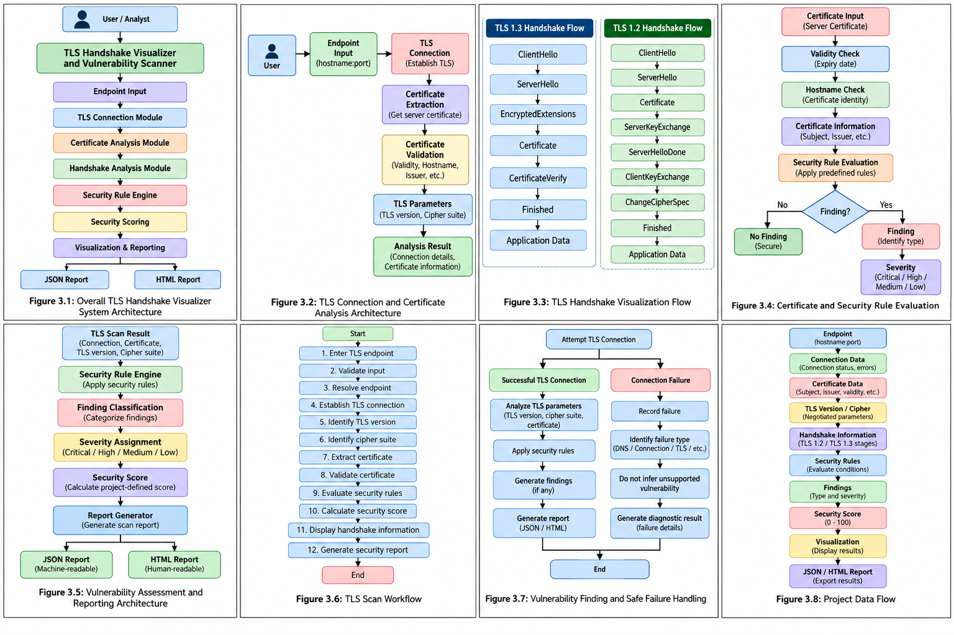

Module 1: TLS Connection and Certificate Analysis

Responsibilities:

Negotiated TLS version.

Cipher suite.

Server certificate.

Certificate subject.

Certificate issuer.

Certificate validity period.

Hostname verification information.

Figure 3.2: Module 1 Architecture





Module 2: TLS Handshake Visualization and Reporting

This module represents the major stages of TLS handshakes.

The visualization allows users to understand the logical progression from connection initiation to protected application communication.

Figure 3.5: Module 2 Architecture



Module 3: Vulnerability Assessment and Security Scoring

The security-rule engine evaluates collected information against predefined project rules.

Examples include:

CERT_EXPIRED — expired certificate.

HOSTNAME_MISMATCH — certificate identity does not match the requested hostname.

LEGACY_CIPHER — selected legacy/weak cipher configuration.

Each finding is assigned a severity level and contributes to the project-defined security score.

3.6 Trade-off Analysis

Table 3.6: Design Trade-off Analysis
Design Decision | Alternative Considered | Benefit | Disadvantage | Final Decision
TLS Protocol Analysis | TLS 1.2 vs TLS 1.3 | Supports comparison of widely relevant TLS versions | Different handshake structures increase visualization complexity | TLS 1.2 and TLS 1.3 support
TLS Implementation | Build TLS stack vs use Python/OpenSSL | Established TLS implementation improves reliability | Less low-level protocol control | Python/OpenSSL TLS functionality
Certificate Analysis | Basic extraction vs detailed validation | Detailed validation provides better security information | Requires additional processing | Detailed certificate analysis
Handshake Visualization | Text output vs graphical flow | Graphical flow improves understanding | Additional UI/design effort | Visual handshake flow
Vulnerability Detection | Manual checking vs automated rules | Automated rules improve repeatability | Limited to implemented rules | Deterministic security rules

3.7 Sustainability, Ethics, Safety, Risk & Security

Table 3.7: Sustainability, Ethics and Security Considerations
Domain | Consideration | Evidence Evaluated | Impact on Final Design
Sustainability | Efficient software-based security analysis | Local controlled TLS testing reduces unnecessary external traffic | Lightweight software architecture selected
Sustainability | Reduced infrastructure requirement | No specialized hardware required | Python/OpenSSL-based implementation
Ethics | Authorized security testing | Scanner is intended for controlled or authorized endpoints | No unauthorized scanning or exploitation
Ethics | Protection of sensitive information | TLS certificates and scan results may contain system information | Avoid unnecessary sensitive data collection

Table 3.8: Risk Register
Risk | Likelihood | Severity | Risk Level | Mitigation | Residual Risk
Incorrect TLS analysis | Medium | High | High | Validate results using controlled TLS endpoints | Low
Certificate Misinterpretation | Low | High | Medium | Use standard certificate fields and validation mechanisms | Low
False-Positive Finding | Medium | High | High | Use deterministic rules and evidence-based conditions | Low
False-Negative Finding | Medium | High | High | Clearly define scanner scope and security rules | Medium
Connection Failure | Medium | Medium | Medium | Structured exception and failure handling | Low
Unsupported TLS Configuration | Medium | Medium | Medium | Report unsupported state without unsupported inference | Low

CHAPTER 4

IMPLEMENTATION, TESTING & RESULTS, PROJECT MANAGEMENT

4.1 Development Approach & Resources

The TLS Handshake Visualizer and Vulnerability Scanner follows a modular development approach. The application is divided into two major modules: TLS connection and certificate analysis, followed by TLS handshake visualization and vulnerability assessment/reporting. Each module is developed and tested independently before integration.

The development process includes requirement analysis, system design, TLS connection implementation, certificate-analysis implementation, handshake-visualization development, security-rule implementation, report generation, testing, and evaluation.

4.2 Software Implementation & Modern Tools Used

Table 4.1: Development Tools and Technologies Used
Tool / Technology | Purpose | Stage Used
Python | Core application implementation | Development
Python ssl Module | TLS connection and protocol analysis | Security
OpenSSL | TLS implementation and certificate/cipher testing | Security
HTML | User interface and report structure | Frontend / Reporting
CSS | Interface and report styling | Frontend / Reporting
JavaScript | Client-side visualization and interaction | Frontend
JSON | Structured scan-result storage and reporting | Reporting
Visual Studio Code | Development environment | Development

4.2.1 TLS Connection and Certificate Analysis Implementation

The TLS connection and certificate-analysis module establishes a connection with the specified TLS endpoint and collects the parameters required for security analysis. The module identifies the negotiated TLS version and cipher suite and extracts certificate information for further validation.

Figure 4.1: TLS Scanner Dashboard and Handshake Observation Interface

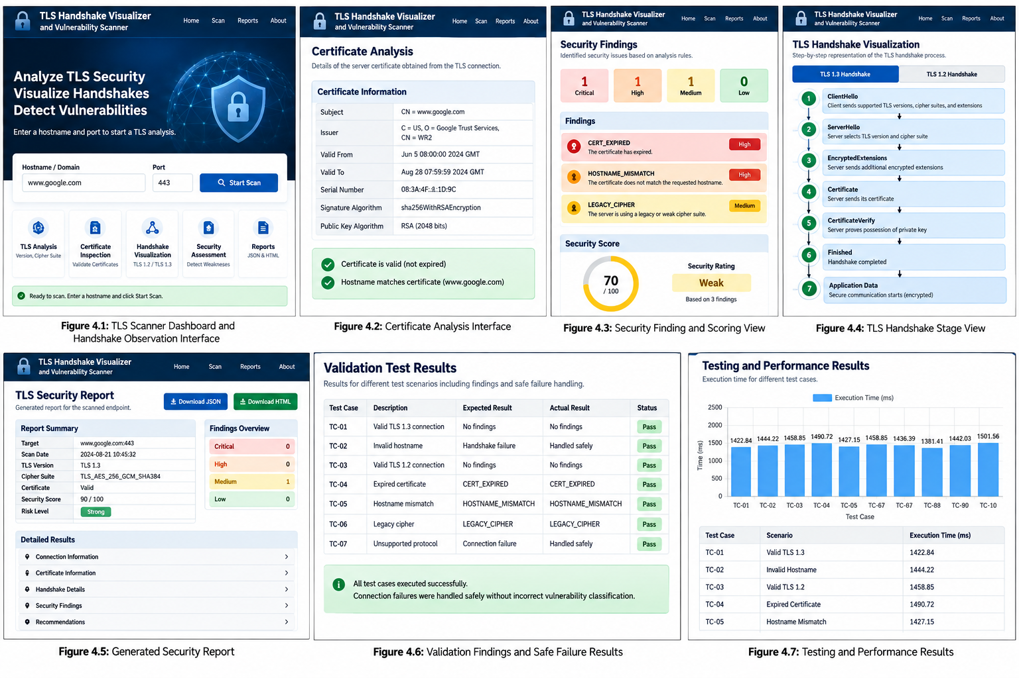

4.2.2 Certificate Analysis

The certificate-analysis component examines the certificate obtained during the TLS connection. It checks certificate validity information and hostname identity and records the result for security-rule evaluation.

The analysis can identify conditions such as an expired certificate and hostname mismatch.

Figure 4.2: Certificate Analysis Interface



4.2.3 Security Finding and Scoring

The implemented rules include:

Expired certificate.

Hostname mismatch.

Legacy cipher configuration.

Other supported TLS configuration conditions.

Figure 4.3: Security Finding and Scoring View



4.2.4 TLS Handshake Visualization



The visualizer presents the major TLS handshake stages in sequence.

4.2.5 Security Report Generation

The reporting component generates structured security results after analysis. The system produces both machine-readable JSON output and human-readable HTML output.

4.3 Test Plan & Verification

Table 4.2: Test Plan and Verification
Requirement | Test Method | Acceptance Criterion
TLS Endpoint Input | Enter valid TLS endpoint | Endpoint accepted successfully
TLS Connection | Connect to controlled TLS service | TLS connection established successfully
TLS Version | Connect to TLS 1.2 and TLS 1.3 endpoints | Correct version identified
Cipher Suite | Perform TLS connection | Negotiated cipher identified
Certificate Analysis | Inspect server certificate | Certificate information extracted
Certificate Expiry | Test with expired certificate | Expired certificate detected
Hostname Verification | Test with mismatched certificate | Hostname mismatch detected

Table 4.3: Functional Test Results
Test Case | Required Value | Achieved Value | Status
Valid TLS 1.3 Connection | TLS 1.3 | TLS 1.3 | Pass
Invalid Endpoint Handling | Safe failure | Structured handshake failure | Pass
Valid TLS 1.2 Connection | TLS 1.2 | TLS 1.2 | Pass
Expired Certificate | Finding detected | CERT_EXPIRED – High | Pass
Hostname Mismatch | Finding detected | HOSTNAME_MISMATCH – High | Pass
TLS 1.2 Parameter Extraction | Correct parameters | Correct parameters | Pass
TLS 1.3 Parameter Extraction | Correct parameters | Correct parameters | Pass
Deprecated TLS Compatibility | Safe handling | Unsupported/refused connection handled safely | Pass

4.4 Results

The TLS Handshake Visualizer and Vulnerability Scanner successfully demonstrates TLS connection analysis, certificate inspection, handshake visualization, vulnerability detection, security scoring, and structured reporting.

The major results include:

Successful TLS 1.3 connection analysis.

Successful TLS 1.2 connection analysis.

Correct TLS-version extraction.

Correct cipher-suite extraction.

Certificate information extraction.

Detection of expired certificates.

Detection of hostname mismatches.

Figure 4.6: Validation Findings and Safe Failure Results



Figure 4.7: Testing and Performance Results



4.5 Data Analysis & Engineering Judgment

The testing results indicate that the proposed system meets the major functional requirements of TLS endpoint analysis, certificate inspection, security-rule evaluation, handshake visualization, and report generation.

The controlled validation confirms that the scanner correctly identifies TLS 1.2 and TLS 1.3 connections and extracts the corresponding negotiated cipher suites.

The certificate tests demonstrate that the system can identify an expired certificate and a hostname mismatch as security findings.

The legacy-cipher test confirms that the security-rule engine can identify the configured legacy cipher condition.

4.6 Comparison with Existing Solutions & Achievement of Objectives

Table 4.4: Comparison with Existing Solutions and Objective Achievement
Objective | Evidence | Achievement
TLS connection analysis | Controlled TLS connection testing | Fully Achieved
TLS version identification | TLS 1.2 and TLS 1.3 test results | Fully Achieved
Cipher-suite identification | Negotiated cipher extraction | Fully Achieved
Certificate analysis | Certificate validation testing | Fully Achieved
TLS handshake visualization | TLS 1.2 and TLS 1.3 handshake representation | Fully Achieved
Vulnerability detection | Expired certificate, hostname mismatch and legacy cipher tests | Fully Achieved
Security scoring | Project-defined score generated for findings | Fully Achieved

4.7 Strengths & Limitations

Strengths

Secure authentication.

TLS 1.2 and TLS 1.3 analysis.

TLS handshake visualization.

Certificate inspection.

Hostname verification.

Expired certificate detection.

Legacy cipher detection.

Deterministic security rules.

Limitations

Vulnerability detection is limited to the implemented security rules.

The scanner does not perform exploitation of detected vulnerabilities.

Unsupported TLS configurations may not be reproducible on modern OpenSSL versions.

Security analysis depends on the TLS capabilities of the underlying Python/OpenSSL environment.

4.8 Project Planning, Roles & Budget

Project Milestones
Phase | Activity
Phase 1 | Problem identification and requirement analysis
Phase 2 | Literature review
Phase 3 | System design
Phase 4 | TLS connection and certificate-analysis development
Phase 5 | Handshake visualization and vulnerability-scanner development
Phase 6 | Integration
Phase 7 | Testing
Phase 8 | Documentation and final review

Table 4.5: Project Roles and Contributions
Student | Assigned Responsibility | Actual Contribution
Student 1 | TLS connection, SNI and certificate analysis | 50%
Student 2 | Handshake visualization and security reporting | 50%
 | Vulnerability rules, scoring and validation

Table 4.6: Estimated Project Budget
Item | Estimated Cost | Actual Cost
Software Tools | ₹0 | ₹0
Development Environment | ₹0 | ₹0
Internet and Testing | ₹500 | ₹500
Documentation | ₹300 | ₹300
Hosting / Deployment | ₹500 | ₹500
Total | ₹1,300 | ₹1,300

CHAPTER 5

CONCLUSION, FUTURE WORK AND REFLECTION

5.1 Conclusion

The TLS Handshake Visualizer and Vulnerability Scanner was developed to address the difficulty of understanding TLS handshake operations and identifying common TLS security configuration issues. The project integrates TLS connection analysis, certificate inspection, handshake visualization, vulnerability assessment, security scoring, and structured security reporting into a single system.

The project successfully demonstrates that TLS security information can be collected and presented in an understandable form by analyzing the negotiated TLS version, cipher suite, X.509 certificate information, certificate validity, and hostname identity. The handshake visualization provides a clear representation of the major TLS 1.2 and TLS 1.3 communication stages.

Overall, the TLS Handshake Visualizer and Vulnerability Scanner demonstrates a practical approach to integrating cryptography and network-security concepts into a security-analysis application for understanding TLS communication and identifying selected configuration-related security weaknesses.

5.2 Future Work

The system can be enhanced in the future by implementing:

Comprehensive TLS configuration and cipher-suite analysis.

Support for additional TLS security checks.

Automated detection of deprecated TLS protocol versions.

Certificate-chain and trust-store analysis.

Certificate transparency and revocation-status checking.

Advanced certificate and public-key algorithm analysis.

5.3 Professional Learning & Individual Reflection

New Knowledge Acquired

Fundamentals of cryptography.

Transport Layer Security concepts.

TLS 1.2 and TLS 1.3 handshake mechanisms.

X.509 digital certificates.

Public-key and symmetric cryptography.

Cipher suites and cryptographic algorithms.

Certificate validation and hostname verification.

Vulnerability assessment principles.

Engineering & Professional Skills Developed

System design.

Secure software development.

Problem-solving.

Testing and debugging.

Team collaboration.

Technical documentation.

Project management.

INDIVIDUAL REFLECTION — STUDENT 1

During the development of the TLS Handshake Visualizer and Vulnerability Scanner, I was mainly responsible for the TLS connection and certificate-analysis functionality. The most challenging part was understanding how TLS connections, certificate information, and hostname verification could be collected and analyzed correctly without incorrectly interpreting connection failures as security vulnerabilities. I contributed to the implementation of TLS connection handling, certificate extraction, and validation-related functionality. Through this project, I gained practical knowledge of TLS communication, X.509 certificates, cryptographic protection, and secure software development. If the project is repeated, I would improve the certificate-analysis mechanism by adding more advanced certificate-chain validation and monitoring features.

INDIVIDUAL REFLECTION — STUDENT 2

I was mainly responsible for the TLS handshake visualization and security reporting module of the project. The major challenge was designing a clear representation of the TLS 1.2 and TLS 1.3 handshake processes while ensuring that the displayed stages accurately represented the protocol flow. I contributed to the design of the handshake visualization and the organization of security information into structured reports. This project helped me understand the importance of TLS protocol operation, handshake sequencing, security reporting, and technical visualization. If the project is further developed, I would implement more interactive handshake visualization features and detailed protocol-level reporting.

INDIVIDUAL REFLECTION — STUDENT 3

I was mainly responsible for the vulnerability assessment, security rules, scoring, and validation module of the project. The major challenge was developing security rules that could identify actual configuration weaknesses while avoiding unsupported vulnerability claims when a TLS connection failed or a configuration could not be tested. I contributed to the implementation of security findings, severity classification, project-defined security scoring, and controlled test validation. This project helped me understand practical vulnerability assessment, security testing, risk classification, and engineering judgment. If the project is further developed, I would implement additional TLS security checks, broader vulnerability detection, and more advanced security assessment capabilities.

REFERENCES

[1] E. Rescorla, “The Transport Layer Security (TLS) Protocol Version 1.3,” RFC 9846, Internet Engineering Task Force, July 2026.

[2] T. Dierks and E. Rescorla, “The Transport Layer Security (TLS) Protocol Version 1.2,” RFC 5246, Internet Engineering Task Force, August 2008.

[3] Y. Sheffer, P. Saint-Andre, and T. Fossati, “Recommendations for Secure Use of Transport Layer Security (TLS) and Datagram Transport Layer Security (DTLS),” RFC 9325, Internet Engineering Task Force, November 2022.

[4] R. Salz and N. Aviram, “New Protocols Using TLS Must Require TLS 1.3,” RFC 9852, Internet Engineering Task Force, July 2026.

[5] K. Moriarty and S. Farrell, “Deprecating TLS 1.0 and TLS 1.1,” RFC 8996, Internet Engineering Task Force, March 2021.

[6] K. A. McKay and D. A. Cooper, “Guidelines for the Selection, Configuration, and Use of Transport Layer Security (TLS) Implementations,” NIST Special Publication 800-52 Revision 2, National Institute of Standards and Technology, 2019.

[7] OWASP Foundation, “Transport Layer Security Cheat Sheet,” OWASP Cheat Sheet Series.

[8] OpenSSL Project, “OpenSSL Documentation and s_client TLS Diagnostic Utility,” OpenSSL Documentation.

[9] Python Software Foundation, “ssl — TLS/SSL wrapper for socket objects,” Python Documentation.

[10] Qualys SSL Labs, “SSL Server Test,” Qualys, Inc. The service provides deep analysis of the configuration of public SSL/TLS web servers.

[11] D. W. et al., “testssl.sh — Testing TLS/SSL encryption anywhere on any port,” Open-source TLS testing project.

[12] R. Merget, J. Somorovsky, N. Aviram, C. Young, J. Fliegenschmidt, J. Schwenk, and Y. Shavitt, “Scalable Scanning and Automatic Classification of TLS Padding Oracle Vulnerabilities,” 28th USENIX Security Symposium, 2019.

APPENDICES

APPENDIX A

DETAILED CALCULATIONS

A.1 TLS Security Scoring Calculation

The TLS Handshake Visualizer and Vulnerability Scanner uses a project-defined security scoring mechanism to summarize detected findings.

The security score is calculated using:

S = max(0, min(100, 100 − 30C − 20H − 10M − 5L))

Where:

S = Security score

C = Number of Critical findings

H = Number of High findings

M = Number of Medium findings

L = Number of Low findings

For example, if a scan produces:

Critical findings = 0

High findings = 1

Medium findings = 0

Low findings = 0

Then:

S = 100 − (30 × 0) − (20 × 1) − (10 × 0) − (5 × 0)

S = 80

Therefore, the resulting project-defined security score is:

80/100

The score bands used by the project are:
Score | Security Band
90–100 | Strong
70–89 | Moderate
40–69 | Weak
0–39 | Critical

The scoring system is a project-defined heuristic and is not an industry-standard security rating.

A.2 TLS Handshake Stage Analysis

TLS 1.3

The major TLS 1.3 handshake stages represented by the visualizer are:

ClientHello

ServerHello

EncryptedExtensions

Certificate

CertificateVerify

Finished

Application Data

The sequence can be represented as:

ClientHello → ServerHello → EncryptedExtensions → Certificate → CertificateVerify → Finished → Application Data

TLS 1.2

The major TLS 1.2 handshake stages represented by the visualizer are:

ClientHello

ServerHello

Certificate

ServerKeyExchange

ServerHelloDone

ClientKeyExchange

ChangeCipherSpec

Finished

Application Data

The sequence can be represented as:

ClientHello → ServerHello → Certificate → ServerKeyExchange → ServerHelloDone → ClientKeyExchange → ChangeCipherSpec → Finished → Application Data

A.3 Certificate Validity Calculation

Certificate validity is evaluated using the certificate's validity interval.

The certificate is considered valid when:

Not Before ≤ Current Time ≤ Not After

Where:

Not Before = certificate validity start time.

Current Time = time at which the certificate is evaluated.

Not After = certificate expiration time.

If:

Current Time > Not After

the certificate is classified as expired.

If the requested hostname does not match the identity represented by the certificate's applicable hostname fields, the scanner can generate the:

HOSTNAME_MISMATCH

finding.

A.4 Scan Execution Time

The TLS scan execution time is calculated using:

Scan Time = End Time − Start Time

The execution time is recorded in milliseconds.

The project validation results include the following measured scan times:
Test Case | Execution Time
TC-01 | 1422.84 ms
TC-02 | 1444.22 ms
TC-03 | 1444.22 ms
TC-04 | 1490.72 ms
TC-05 | 1427.15 ms
TC-06 | 1458.85 ms
TC-07 | 1436.39 ms
TC-08 | 1381.41 ms
TC-09 | 1442.03 ms

The median execution time is approximately:

1436.39 ms

The mean execution time across the nine timed test cases is approximately:

1434.71 ms

A.5 Report Size Measurement

The scanner generates two report formats.
Report Type | Measured Size
JSON Report | 9,563 bytes
HTML Report | 1,890 bytes

The JSON report provides machine-readable structured results, while the HTML report provides a human-readable presentation of the scan results.

APPENDIX B

ENGINEERING DRAWINGS / SYSTEM DIAGRAMS

This appendix contains the major system-level engineering diagrams used to explain the architecture and workflow of the TLS Handshake Visualizer and Vulnerability Scanner.

The diagrams demonstrate how different components communicate and how TLS information is collected, analyzed, evaluated, visualized, and reported.

B.1 Overall System Architecture

The TLS Handshake Visualizer and Vulnerability Scanner architecture consists of multiple interconnected components designed to provide TLS analysis and security assessment.

Main Components

User Interface

Endpoint Input Module

TLS Connection Module

Certificate Analysis Module

TLS Handshake Visualization Storage

Vulnerability Assessment Module

Security Scoring Module

Report Generation Module

JSON / HTML Output

System Flow

User → TLS Scanner → Endpoint Input → TLS Connection → Certificate Analysis → Handshake Analysis → Security Rule Engine → Security Score → Visualization / Reporting

For reporting:

Scan Result → Report Generator → JSON Report / HTML Report

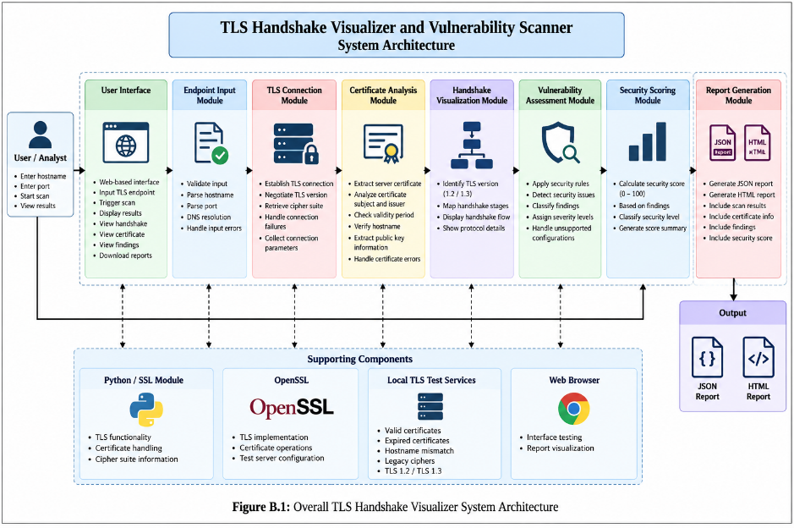

B.2 Module 1 Architecture — TLS Connection & Certificate Analysis

Module 1 is responsible for establishing the TLS connection and collecting the information required for certificate and security analysis.

Main Functions

TLS endpoint input.

DNS resolution.

TLS connection establishment.

TLS version detection.

Cipher-suite extraction.

Server certificate extraction.

Certificate subject analysis.

Certificate issuer analysis.

Certificate validity analysis.

Hostname verification.

Connection-error handling.

Module Workflow

Endpoint Input

↓

DNS / Connection

↓

TLS Handshake

↓

TLS Version & Cipher Extraction

↓

Certificate Extraction

↓

Certificate Validation

↓

Analysis Result

The module maintains important information such as:

Target hostname.

Target port.

TLS version.

Cipher suite.

Certificate subject.

Certificate issuer.

Certificate validity.

Hostname verification result.

Connection status.

APPENDIX C

SOURCE CODE / CODE REPOSITORY INFORMATION

This appendix provides information about the source-code organization and major software components used in the TLS Handshake Visualizer and Vulnerability Scanner.

Only essential code excerpts should be included in the final report. The complete implementation should be maintained separately in the approved source-code repository.

C.1 Suggested Project Structure

TLS-Handshake-Visualizer/

│

├── frontend/

│ ├── index.html

│ ├── scanner.html

│ ├── handshake.html

│ ├── report.html

│ └── styles/

│

├── backend/

│ ├── app.py

│ ├── tls_scanner.py

│ ├── certificate_analyzer.py

│ ├── handshake_visualizer.py

│ ├── vulnerability_scanner.py

│ ├── security_scoring.py

│ └── report_generator.py

│

├── tests/

│ ├── test_tls13.py

│ ├── test_tls12.py

│ ├── test_certificate.py

│ ├── test_hostname.py

│ └── test_cipher.py

│

├── reports/

│ ├── json/

│ └── html/

│

├── test-certs/

│ ├── valid/

│ ├── expired/

│ └── hostname-mismatch/

│

└── README.md

APPENDIX D

SOFTWARE / TECHNOLOGY DOCUMENTATION

This appendix describes the major software technologies and development tools used for the TLS Handshake Visualizer and Vulnerability Scanner.

D.1 Python

Python is used as the primary programming language for implementing the TLS scanner and security-analysis logic.

Main Functions

Application logic.

TLS connection handling.

Certificate processing.

Security-rule evaluation.

Data processing.

Report generation.

Testing.

D.2 Python SSL Module

The Python ssl module provides access to TLS/SSL functionality.

Responsibilities

Creating TLS contexts.

Establishing secure connections.

Negotiating TLS versions.

Obtaining cipher information.

Obtaining peer certificates.

Performing certificate verification.

The module allows the project to use established TLS functionality instead of implementing the TLS protocol from scratch.

D.3 OpenSSL

OpenSSL provides the underlying cryptographic and TLS functionality used by the development and testing environment.

Main Functions

TLS protocol implementation.

Certificate processing.

Cryptographic operations.

TLS test-service configuration.

Cipher-suite testing.

Controlled security validation.

OpenSSL is also used to create and operate controlled test configurations for TLS 1.2, TLS 1.3, certificate expiration, hostname mismatch, and legacy cipher testing.

D.4 HTML, CSS and JavaScript

HTML, CSS, and JavaScript are used to create the user interface and present TLS analysis results.

HTML

Provides the structure for:

Scanner interface.

TLS results.

Certificate information.

Security findings.

Reports.

CSS

Provides:

Page layout.

Tables.

Cards.

Handshake visualization styling.

Security-result presentation.

JavaScript

Provides:

Interface interaction.

Dynamic result presentation.

Handshake-stage interaction.

Report display.

D.5 JSON

JSON is used as the machine-readable report format.

The report can contain:

Target information.

Connection status.

TLS version.

Cipher suite.

Certificate information.

Security findings.

Severity.

Security score.

Timing information.

OUTCOME EVIDENCE MAPPING :

Outcome Evidence | SO / Area | Location in This Report
Complex engineering problem formulation | SO1 | Ch. 1, Ch. 2
Engineering design under constraints | SO2 | Ch. 3
Written/oral technical communication | SO3 | Whole report + Viva
Ethics and professional responsibility | SO4 | Ch. 3 (3.7)
Teamwork and leadership | SO5 | Ch. 4 (4.8)
Experimentation, analysis, engineering judgment | SO6 | Ch. 4 (4.3–4.6)
Independent acquisition of new knowledge | SO7 | Ch. 5 (5.3)
Standards | SO2 | Ch. 3 (3.2)
Sustainability and societal/environmental impact | SO2/SO4 | Ch. 3 (3.7)
Risk assessment and mitigation | SO2/SO4 | Ch. 3 (3.7)
Security considerations | Relevant SO | Ch. 3 (3.7)
Integrated/system-level engineering | SO1/SO2 | Ch. 3 (3.5)
Project planning and management | SO5 | Ch. 4 (4.8)
Individual contribution | SO1–SO7 | Contribution Statement + Ch. 4 (4.8)

